**Presentation Style Explanation**

**HTML**

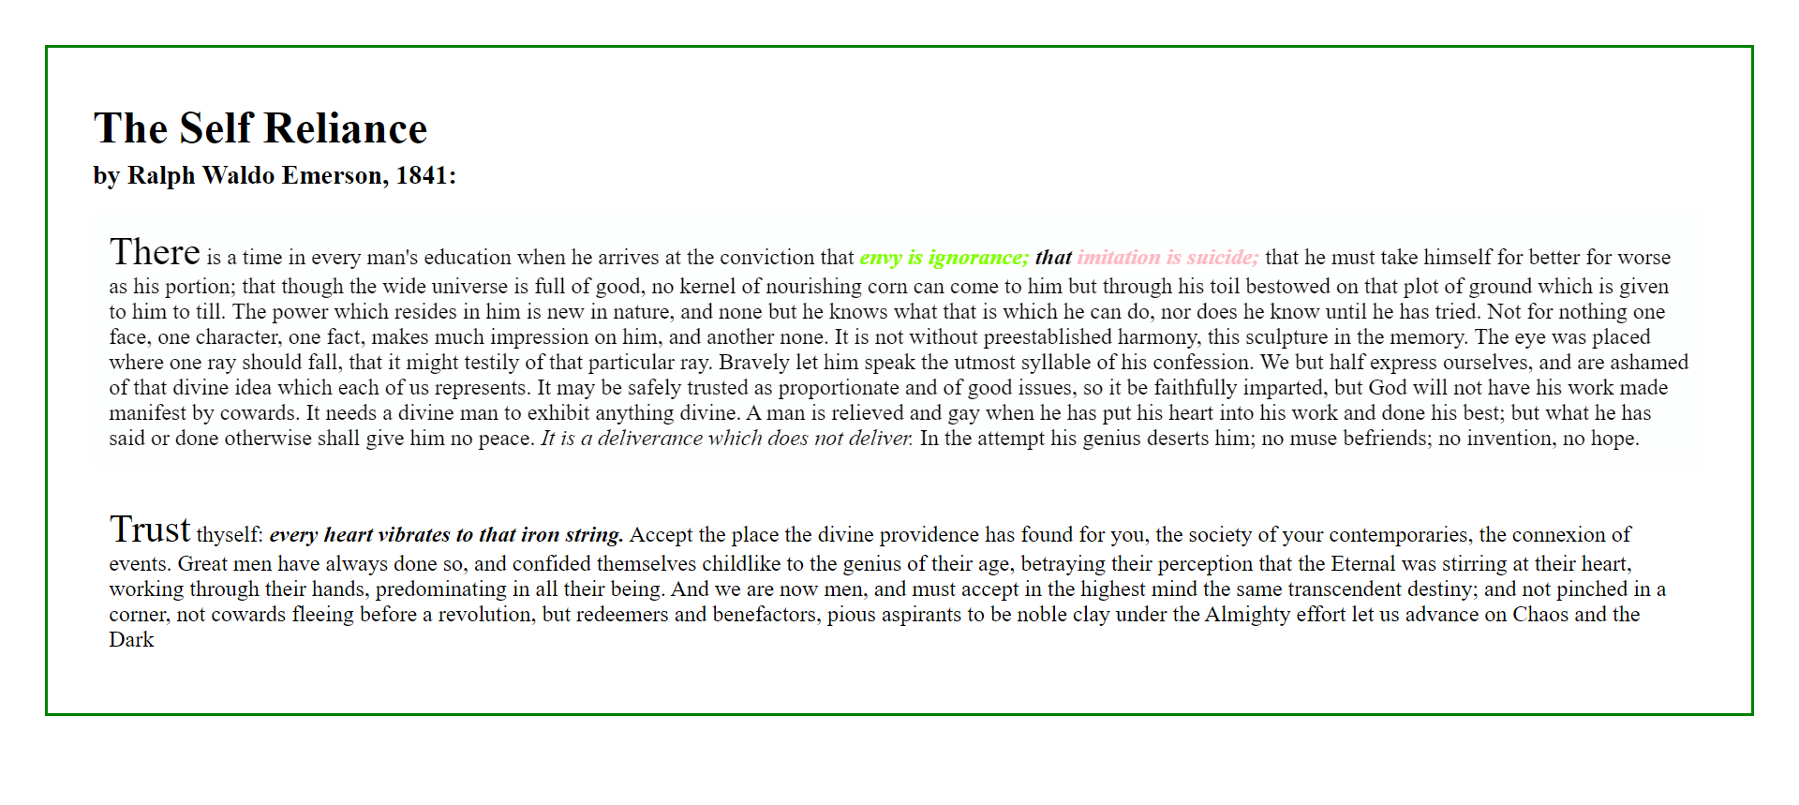

* **Make some padding and margin to the text sample** so that the context will be more concentrated and clear to look at.
* **Make a border** to beautify the text sample.
* **Use a <h1> tag for the title, and the author and the time in <h3> tag** to indicate the title of the text sample.
* **Make the first word of the paragraph bigger** to indicate the starting point of a paragraph.
* **highlight some important phrase** to increase the readability of the context
* **do some animation to catch reader’s eyes:** 
  + when hover to the first paragraph, the background turns into grey; and the background of second paragraph will turns into golden.
* **font family is Times New Roman** asthe context is literary

**Printed paper**

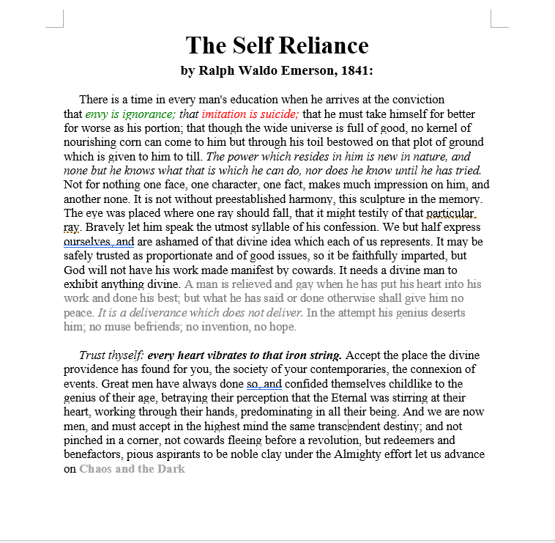

* **Enlarge the title** to point out the main point
* **Make the title centre** as the context is literary
* **font family is Times New Roman** asthe context is literary
* **highlight some important phrase** to increase the readability of the context
* **change some text color** according to the meaning of the context